Elliot Huh

CS340

Module 7

Project 2 README

***Purpose***

The purpose of this project was to provide a software application to help manage and understand databases that were provided for the company Grazioso Salvare. This company specializes in training rescue animals and were provided databases of non-profit Austin Animal shelters. This software application will be able to filter through the data base, provide widgets, charts and sorting options to help users be able to understand and interact with the database. This software application should boost the efficiency and efficacy of the services of Grazioso Salvare.

***Setup***

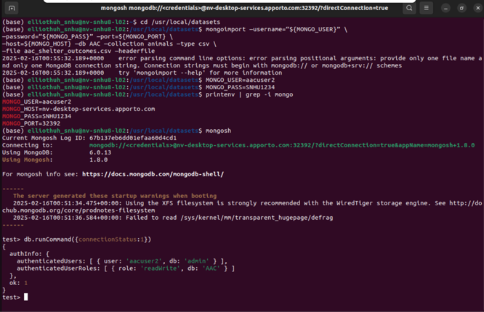

Prior to interacting and starting up the application. It’s important to import the data base and set up proper authentication. MongoDB was utilized to achieve these steps. First the Austin Animal Shelter database was imported into the local system. Then the established authentication usernames and passwords were logged in to properly authenticate the user. Note that the username and password will be needed within the code of application.

***Top of the application/Unique Identifier***

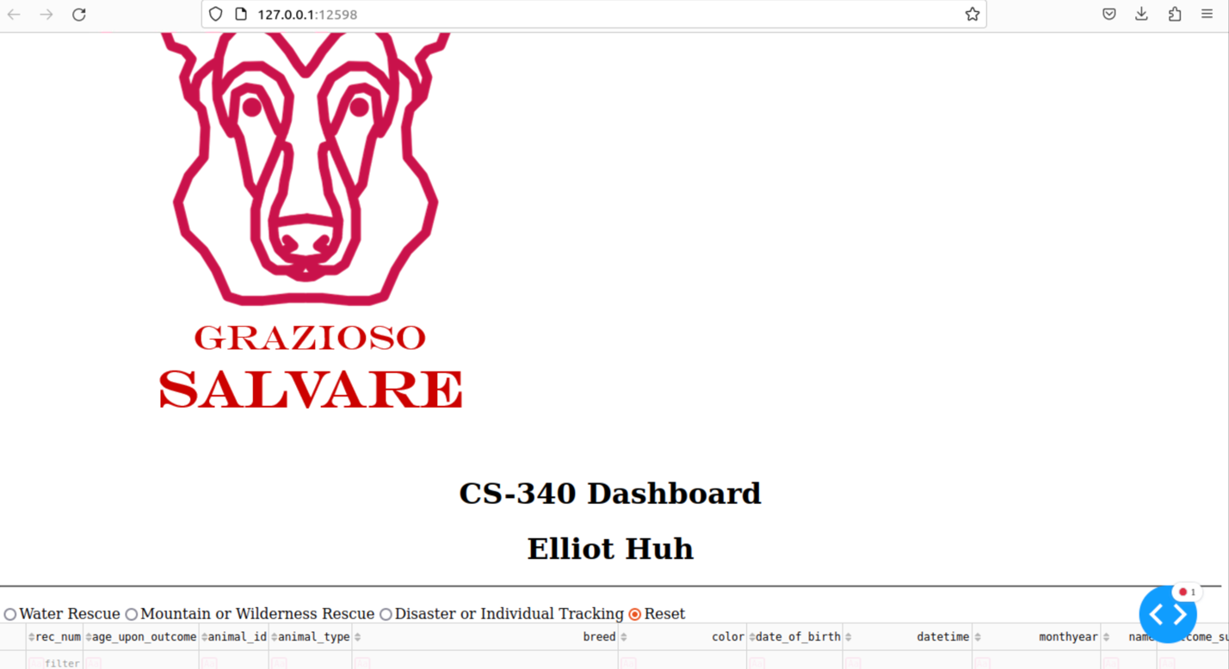

Once the database is imported and all the proper authentication methods are met the application can be deployed. At the top of the application there is a logo of Grazioso Salvare. The title “CS-340 Dashboard” along with my unique identifier which is my name in this example is underneath the logo.

***Full data table/Reset option***

(Data Table)

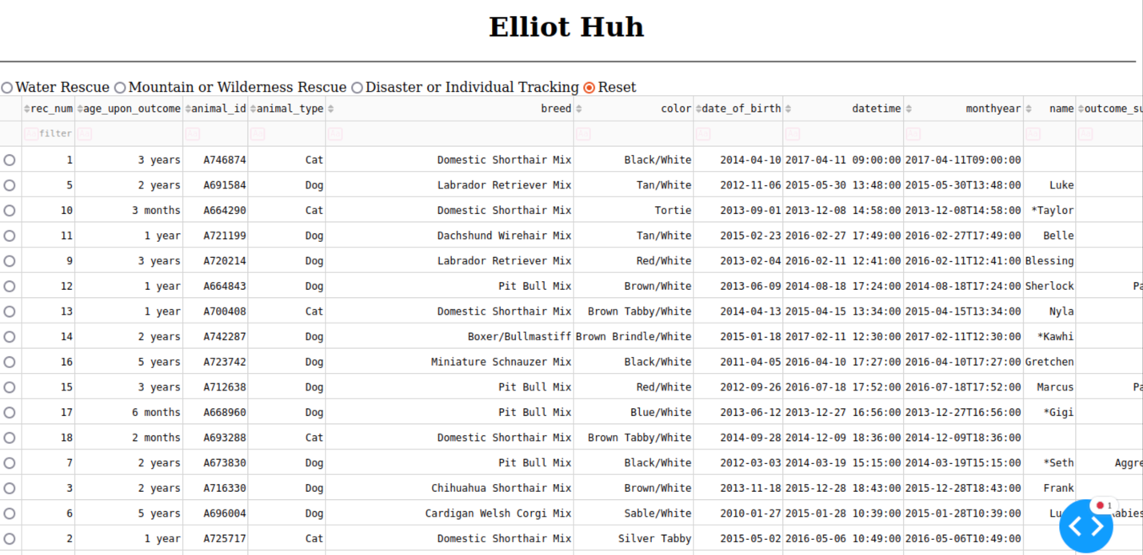

(Data Table Right Side)

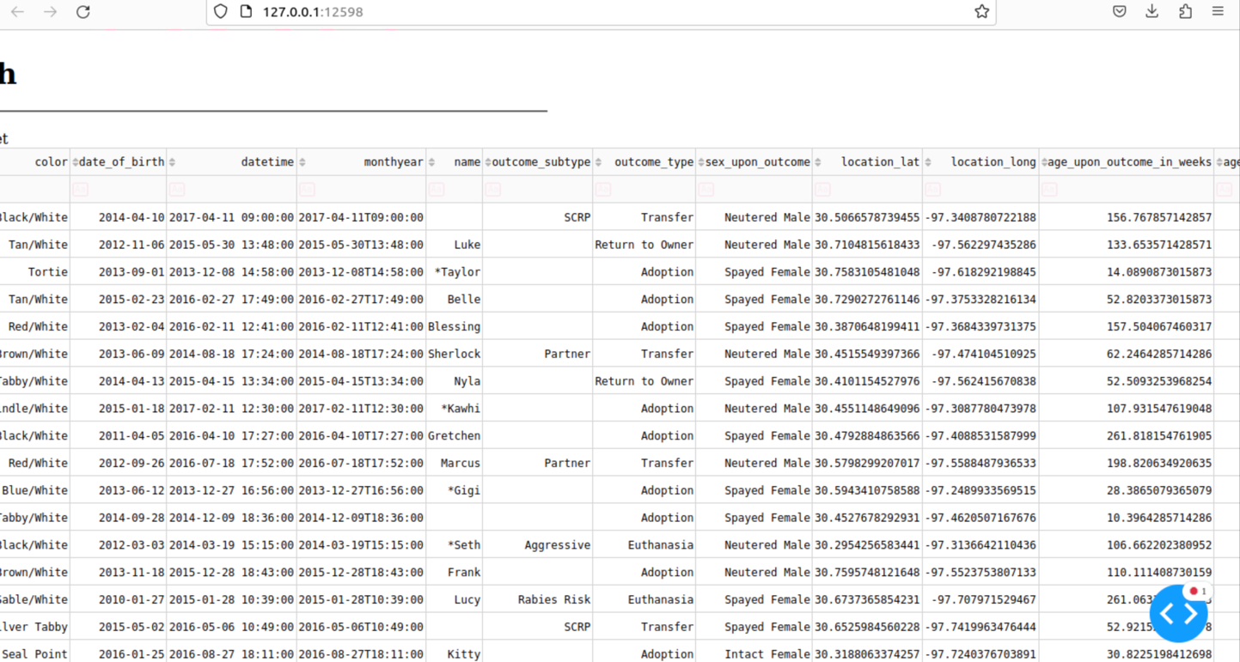

Underneath the title and top of the page the data table is shown. At the top of the data base there is 4 filter options which represent each of the rescue types or situations. Grazioso Salvare has identified unique breeds, genders and training ages that are preferable within these specific rescue scenarios. By clicking on one of the filters it will filter out all other animals and narrow the database down to the specific animals that are preferable to the scenario.

By default, the reset option is already selected. This option shows the data table in its fullest extent with no filters or special circumstances. Users can utilize the reset option to return to the full data display after choosing a specific rescue type. Data table has numerous columns representing information about the specific animals. And rows to show each unique animal.

(Pie Chart and Geolocator Map)

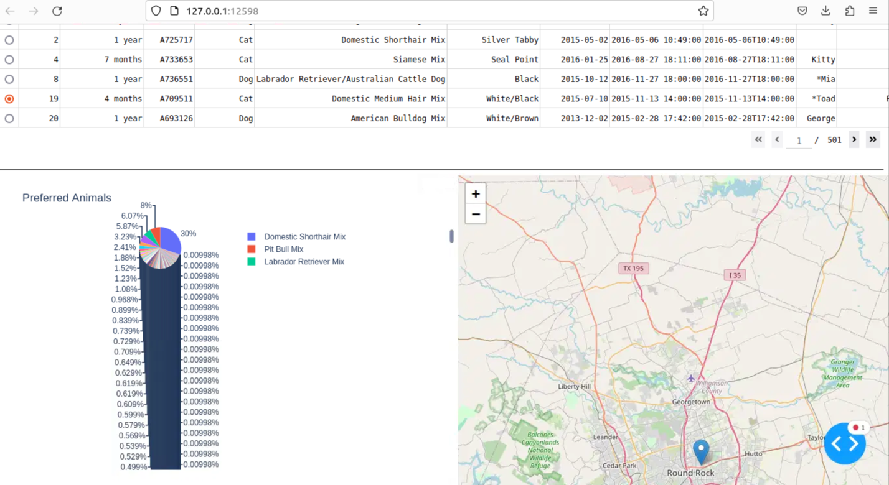

At the bottom of the data table we can see the data table page scroller and then the two additional dynamic widgets that can help deliver the data. The bottom left of the page will show the pie chart. This will pull all the data from the data table and separate all the animals up by breed and put them into a pie chart. The pie chart will be effected by the rescue type filters and will produce a unique pie chart depending on the rescue type chosen.

The bottom right of the screen shows the geolocator map. Each row has a radio selector icon. Once selecting on the row which selects a unique animal, the interactive geolocator map will generate for that specific animal that was selected. The map can scroll and zoom in and out.

(Sorting functionality)

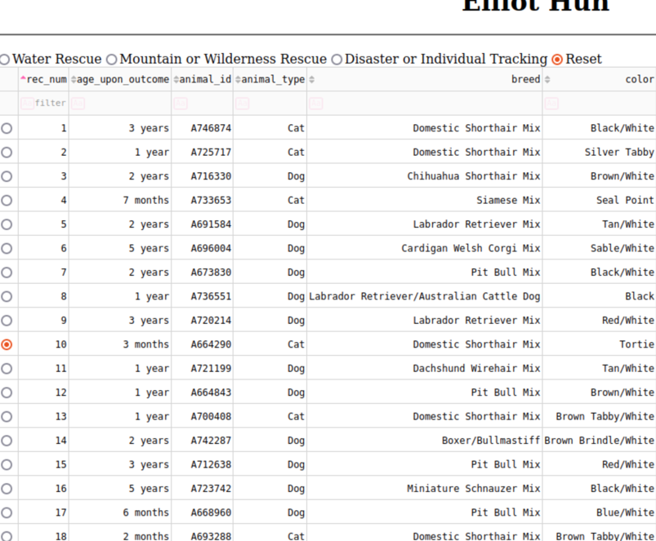

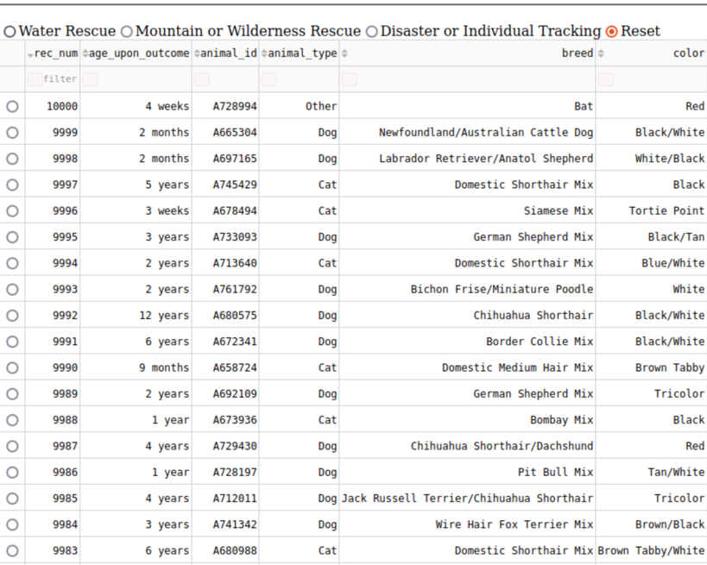

On the data table each column has sorting option. By clicking the small arrows that are associated with each column the user can sort out the data numerically low to high or high to low, or sort alphabetically or reverse alphabetically. Here is an example of the rec_num being sorted.

(Type Filtering Functionality)

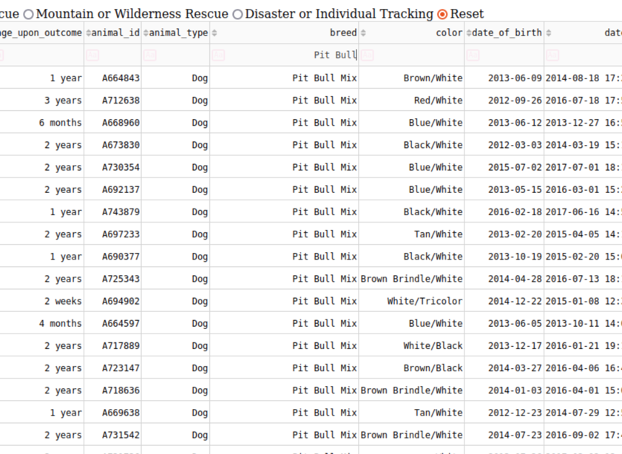

Underneath the sort of functionality of every column there is place for the user to type out what they would like to search for. Users can click on this space and type out the desired information to search for specific items. This is an example of this feature being utilized to find an Pit Bull Breed.

CS-340 Dashboard Specifications Document

“Rescue Type and Preferred Dog Breeds Table”

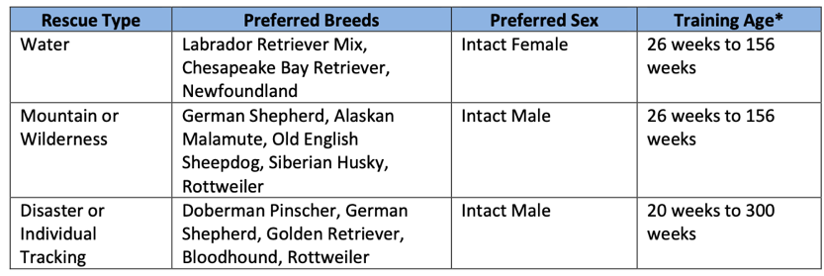

The Rescue type filters were based on this and all filtered queries were built with these specifications and preferences in mind.

***Water Rescue Filter***

(Water Rescue Data Table)

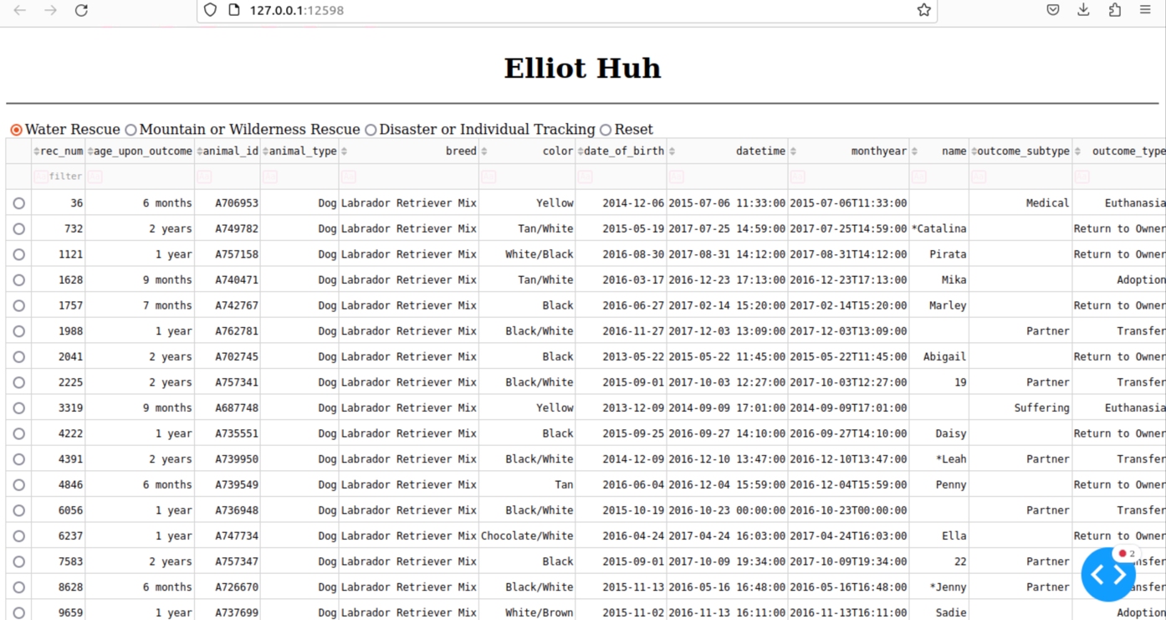

(Water Rescue Data Table Right Side)

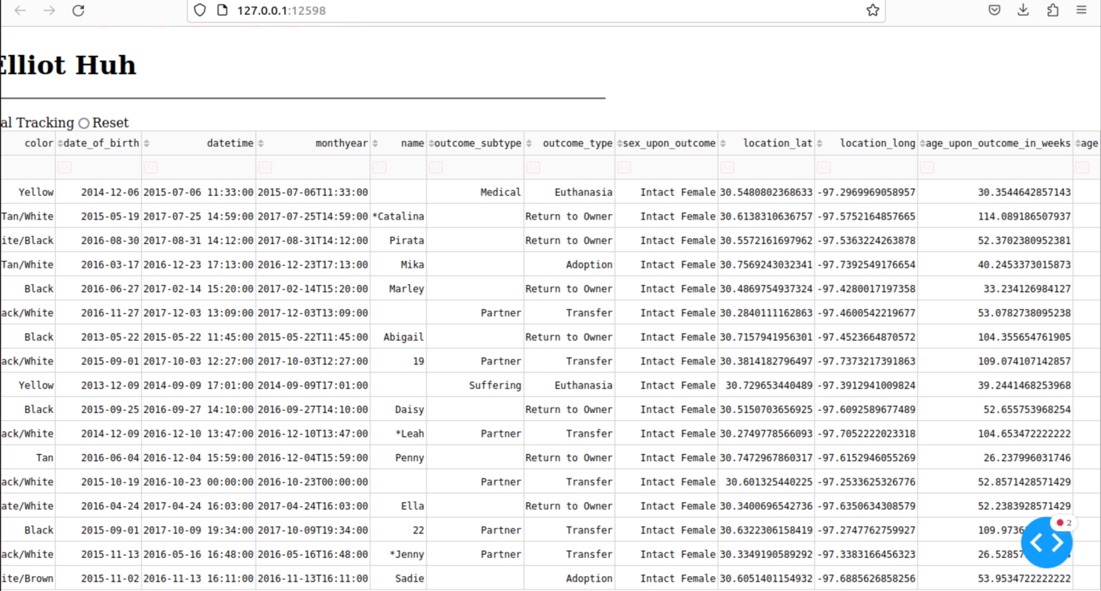

(Water Rescue bottom/ Pie chart and Geolocator map)

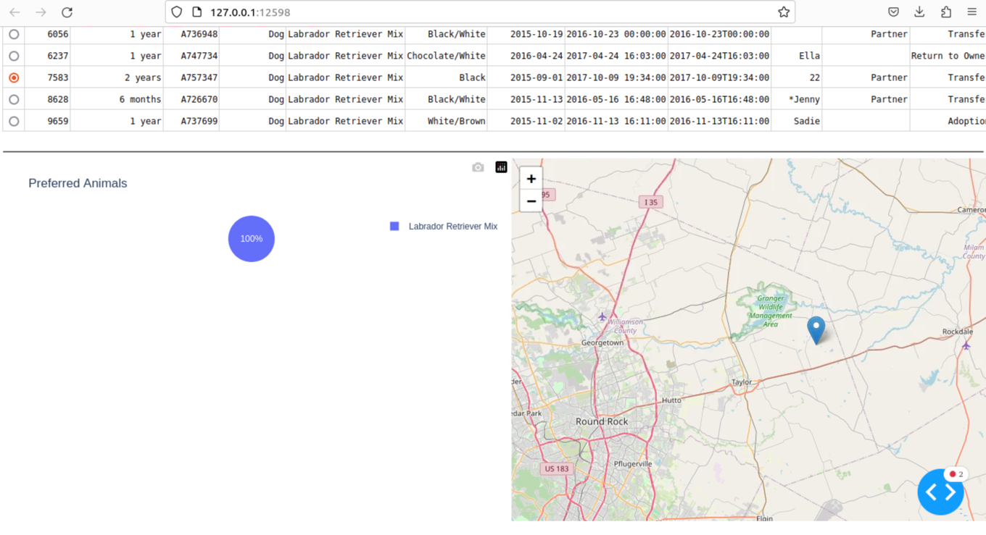

This is an example of the Water rescue filter being utilized. Only Labrador Retriever Mix breed was available for this recue type with this database at this time. The pie chart and data table was updated to reflect the filter being applied.

***Mountain or Wilderness Rescue filter***

(Data table, Pie chart and geolocator map with Mountain or Wilderness Rescue filter applied)

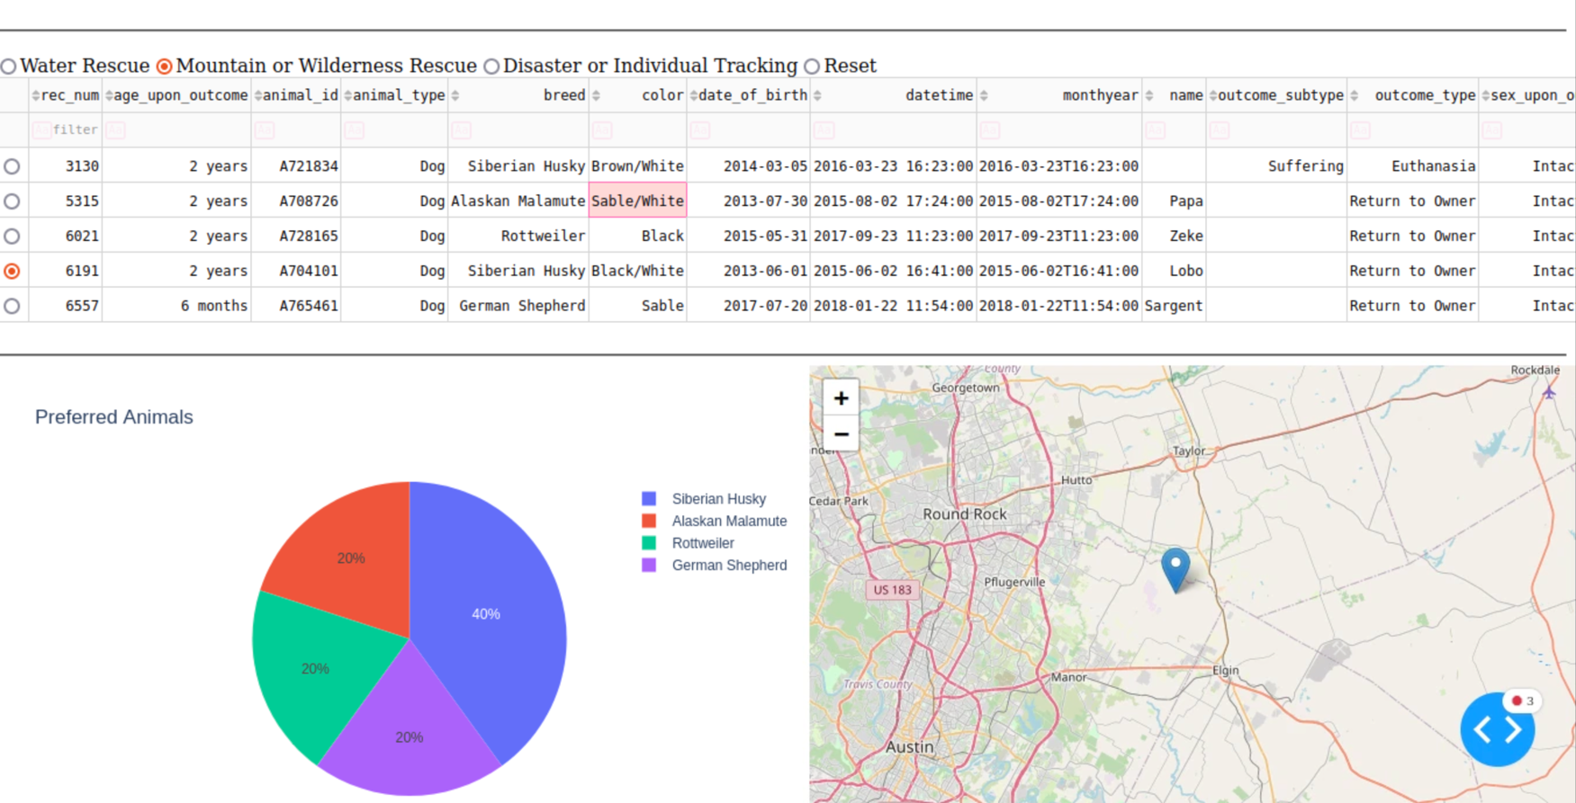

(Right side of the data table)

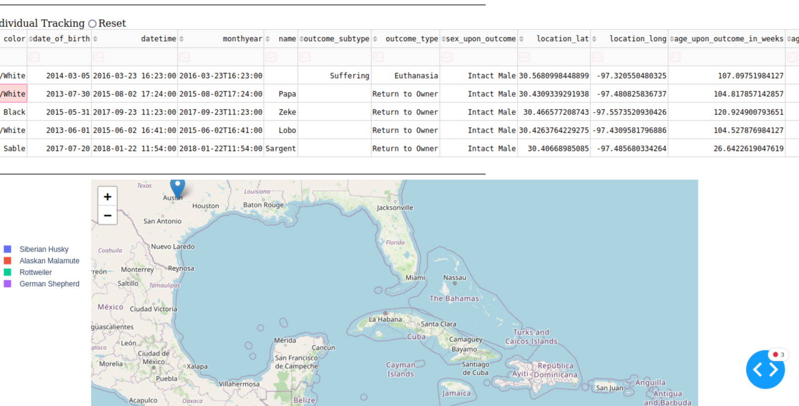

The both charts and displays were updated to show the updated data with the filter.

***Disaster or Individual Tracking filter***

(Data table, pie chart and geolocator with filter of Disaster or Individual tracking applied)

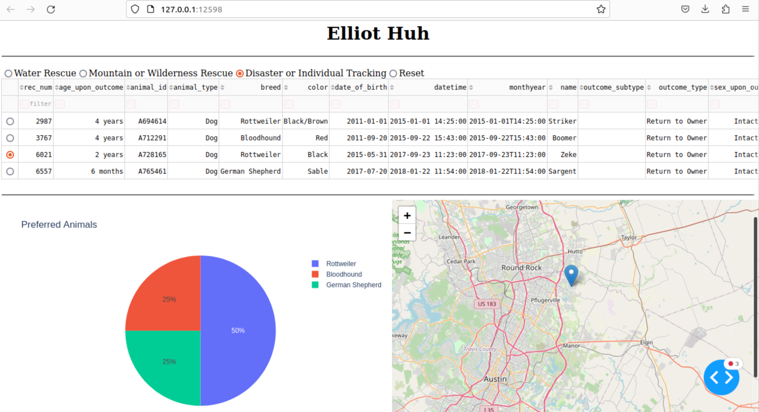

(Right side of the data table)

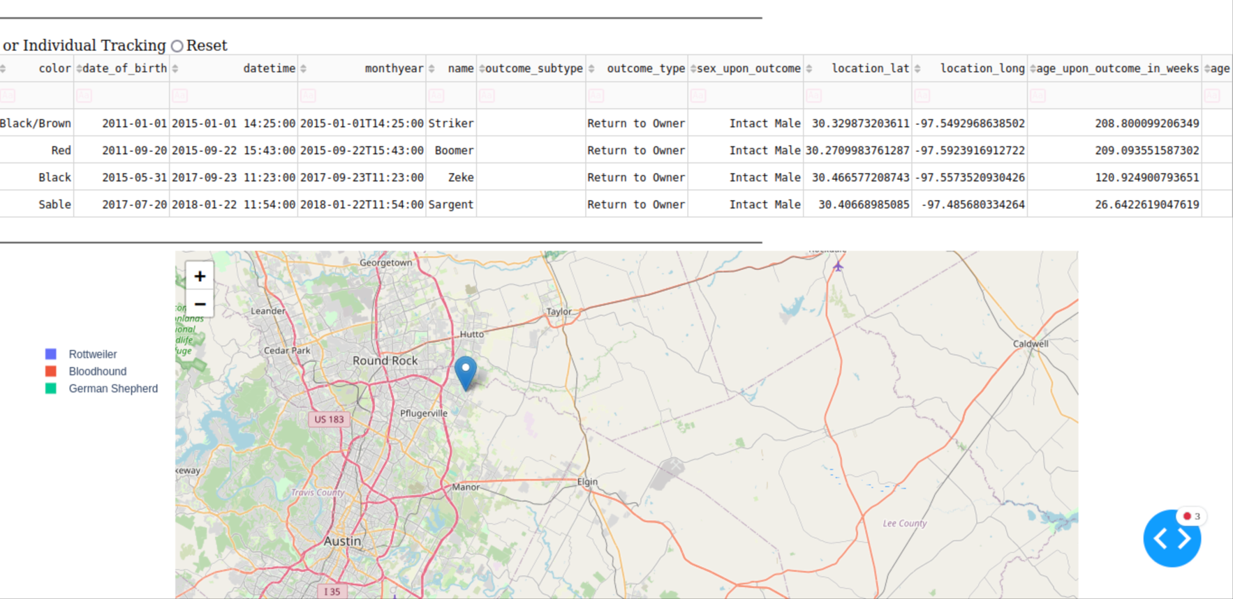

This is an example of all charts and widgets with the associating rescue type filter applied.

***Steps taken***

My first step was to ensure all the prerequisites and set up steps were completed. This included importing the document, ensuring the authentication methods were working properly, and revisiting the CRUD module, and ensuring a successful import of that module into the deployment.

Next step I focused on addressing the FIXME’s and finishing the starter code in its most basic form to get the code to run properly in the first place. This included getting the Grazioso Salvare logo to display properly, getting the initial data table to show and getting the pie chart to display.

Once I finished this step I refined up the code and added in features and aspects to finish and solidify the initial page and set up. I added my unique identifier, search filter, sorting and a selector for the geolocator map.

My final step was to add in the rescue type filters. I added in radio items and 4 filter options. I then had to manipulate the code to properly update and display all the right data. I endured that the data properly took in all the preferences and the pie chart accurately reflected the filters.

***Challenges***

There was much I had to learn throughout this project. Prior to this project I had very little experience with html and had a lot to learn with the displays, functions and numerous scripts that html was capable of. Utilizing resources and learning was critical for steps like sorting and filtering tools within the data table.

I had a lot of trouble with the rescue type filters. I tried to utilize buttons at first but the clicks and troubleshooting with the counters was very troublesome and confusing for me. I ultimately chose radio items which worked a lot better for me. The proper filters and preferences turned out to be a lot simpler to implement than I originally thought so there were some areas that went a lot better for me than I orginally predicted.

***Sources***

SNHU. (n.d.). *CS-340 - snhu - client/server development - STUDOCU*. CS 340 Dashboard Specification Document. https://www.studocu.com/en-us/course/southern-new-hampshire-university/clientserver-development/6643123

*Dash datatable*. Plotly. (n.d.-b). https://dash.plotly.com/datatable

*Pie*. Pie charts in Python. (n.d.). https://plotly.com/python/pie-charts/